Step Definition

**Step 1** Adding a step definition file.

* Create a new Class file in the “step Definition” package and name it as “Test Steps”
* When we run the Feature file as Cucumber feature, the following message will be displayed in the console window:

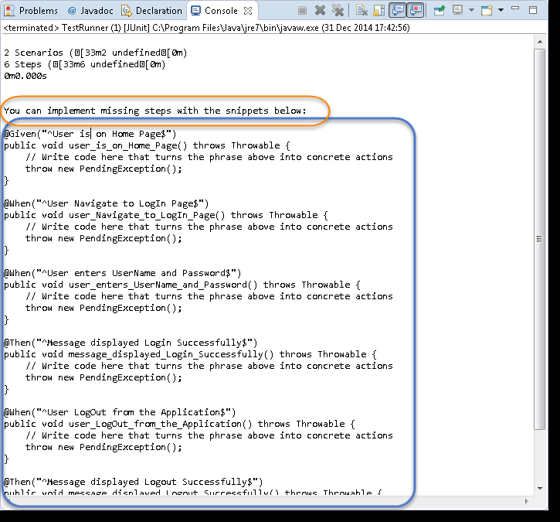

* Copy the complete text marked in a blue box and paste it into the above created Test Steps class.
* The test will show many errors on “@” annotations. At the annotations, import the “cucumber.api.java.en” for all the annotations.

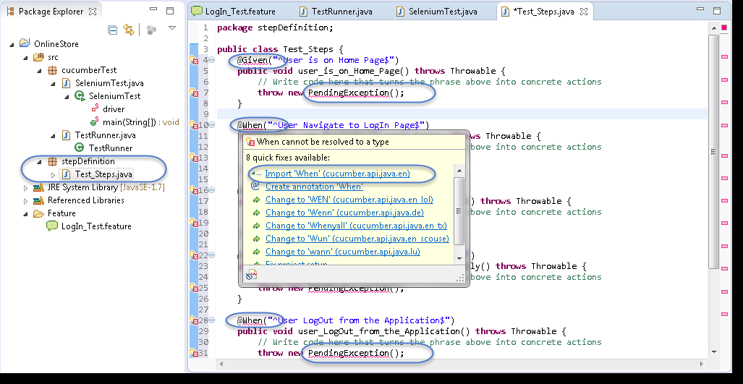

## 

## **2:** Providing implementations using Selenium Java for the Step Definition methods.

* Using Selenium Java, provide the implementation to the first method “@Given (“^User is on Home Page$”)”
* Launch the Browser
* Navigate to Home Page

Method will look like this now:

|  |
| --- |
| **@Given("^User is on Home Page$")**  **public void user_is_on_Home_Page() throws Throwable**  **{**  **driver = new FirefoxDriver();**  **driver.manage().timeouts().implicitlyWait(10, TimeUnit.SECONDS); driver.get("http://www.store.demoqa.com");**  **}** |

## 

* Using Selenium Java, provide the implementation to the second method “@When (“^User Navigate to Login Page$”)”
* Click on the Login link

Method will look like this now:

|  |
| --- |
| @When("^User Navigate to Login Page$")  public void user_Navigate_to_Login_Page() throws Throwable  {  driver.findElement(By.xpath(".//*[@id='account']/a")).click();  } |

* Using Selenium Java, provide the implementation to the second method.

“@When (“^User enters UserName and Password$”)”

* Enter UserName and Password
* Click on Submit button

Method will look like this now:

|  |
| --- |
| @When("^User enters Username and Password$")  public **void** user_enters_Username_and_Password() throws Throwable  {  driver.findElement(By.id("log")).sendKeys("testuser_1");  driver.findElement(By.id("pwd")).sendKeys("Test@123");  driver.findElement(By.id("login")).click();  } |

* Do the same steps for the rest of the methods and the complete Test_Steps class will look like this:

|  |
| --- |
| **package stepDefinition;**    **import java.util.concurrent.TimeUnit;**  **import org.openqa.selenium.By;**  **import org.openqa.selenium.WebDriver;**  **import org.openqa.selenium.firefox.FirefoxDriver;**  **import cucumber.api.java.en.Given;**  **import cucumber.api.java.en.Then;**  **import cucumber.api.java.en.When;**  **public class Test_Steps**  **{ public static WebDriver driver;**  **@Given("^User is on Home Page$")**  **public void user_is_on_Home_Page() throws Throwable{**  **driver = new FirefoxDriver();**  **driver.manage().timeouts().implicitlyWait(10, TimeUnit.SECONDS);**  **driver.get("http://www.store.demoqa.com"); }**    **@When("^User Navigate to LogIn Page$")**  **public void user_Navigate_to_LogIn_Page() throws Throwable {**  **driver.findElement(By.xpath(".//*[@id='account']/a")).click(); }**    **@When("^User enters UserName and Password$")**  **public void user_enters_UserName_and_Password() throws Throwable {**  **driver.findElement(By.id("log")).sendKeys("testuser_1");**  **driver.findElement(By.id("pwd")).sendKeys("Test@123");**  **driver.findElement(By.id("login")).click(); }**    **@Then("^Message displayed Login Successfully$")**  **public void message_displayed_Login_Successfully() throws Throwable{**  **System.out.println("Login Successfully"); }**    **@When("^User LogOut from the Application$")**  **public void user_LogOut_from_the_Application() throws Throwable{**  **driver.findElement (By.xpath(".//*[@id='account_logout']/a")).click(); }**    **@Then("^Message displayed Logout Successfully$")**  **public void message_displayed_Logout_Successfully() throws Throwable {**  **System.out.println("LogOut Successfully"); }}** |